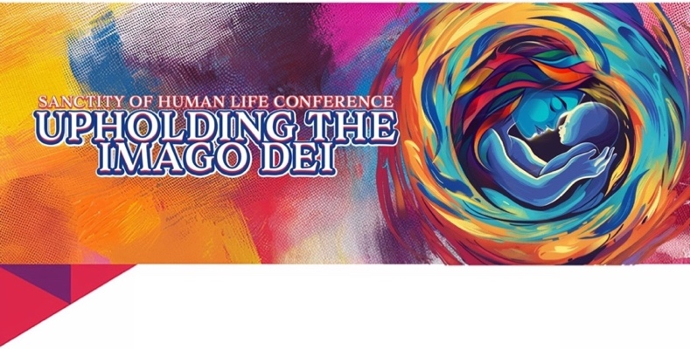

Thank you for your interest in participating at our annual Imago Dei Conference. We believe Christian businesses are an important aspect of our community and we are excited to highlight yours throughout the conference. Below are two packages available for your consideration.

**Imago Dei Sponsorship Packages:**

**Commercial Package:** $1000 Cash or check can be made out to Imago Dei Conference – Includes two (2) tickets to the conference, business name in program, media loop and commercial time.

**Monetary Package:** Cash or Check can be made out to Imago Dei Conference - Includes two (2) tickets to the conference, business name in the program, media loop and public acknowledgement of participation.

**Resource Sponsorship Package:** provided for a minimum of 400 people – Includes two (2) tickets to the conference, business name in program, media loop and public acknowledgement of participation.

**Participation Package** – Allows for posters and flyers to be available at business location, promotes the Imago Dei event on social media platforms or email list. – Includes media loop and public acknowledgement of participation.

If agreed upon, we will be promoting your organization throughout the conference. We want to make sure that your experience at Imago Dei is just as enjoyable as our guests. Please fill out the information below and send to imagodei@rrwm.org.

BUSINESS NAME: _____________________________________________________________________________________

Check one box: COMMERCIAL PACKAGE MONETARY PACKAGE

RESOURCE PACKAGE PARTICIPATION PACKAGE

Attendee (1) Name: __________________________________________________ Phone: _____________________________

Email: _________________________________________________________________________________________________

Food Allergies: _________________________________________________________________________________________

Attendee (2) Name: __________________________________________________ Phone: _____________________________

Email: _________________________________________________________________________________________________

Food Allergies: _________________________________________________________________________________________

Anything specific we can help you with to ensure you are set for success? ___________________________________________

If you have any questions, please email [imagodei@rrwm.org](mailto:imagodei@rrwm.org) or call 702-201-1308, and we will be happy to assist you.

God Bless,

Imago Dei Team

10050 Banburry Cross Drive #110

Las Vegas, NV 89144